Title:
Subtitle

Author

Supervisor: Title Name
Centre for Language and Literature, Lund University
MA in Language and Linguistics, Specialisation
SPVR01 Language and Linguistics: Degree Project – Master's (Two Years) Thesis, 30 credits

Month 201x

Abstract
Whatever the language of the thesis (this depends on the specialisation), the abstract (300-400 words) is normally written in English. But there could be other options. Talk to your supervisor if you have questions.

Keywords: x, y, z…

Acknowledgements
This is an optional part, but it is very good to include it, and thank your informants, co-students, supervisors etc…

Table of contents
List of figures v
List of tables v
Abbreviations v
Headline 1 Introduction 1
Headline 2 Examples, tables and figures 1
Headline 3 References 2
Chapter 2 The syllabus SPVR01 4
2.1 Course content 4
2.2 Course design and assessment 4
Chapter 3 The MA thesis defence 5
References 6
Appendix 7

List of figures

List of tables

Abbreviations
ACC Accusative
COMP Complementiser
PAST Past tense
TOP Topic

Chapter 1 Introduction (Headline 1)

1.1 Examples, tables and figures (Headline 2)
This is a template in MS Word that uses styles. We encourage you to use it, and possibly adjust it in several ways. You are free to change the layout, but make sure you keep to the overall structure. Don’t change the content on the first page (the LU logotype and the name of the programme, of your supervisor, and so on). Use 1.5 between lines, like this.

A new paragraph can be marked with line spacing like this.
Or you could also use indents like this, but you need to be consistent (not like here).

The table of contents and other indexes are best generated by the programme, so learn how to do this.
If you have examples in the text, you should number them as in (1) and (2). If you use example in any other language but English, you should gloss them as in (3). Follow the so-called “Leipzig rules” for glossing as close as possible.

(1) This is an example
(2) And this is another one
(3) Taro-wa sutasuta-to haya-aruki-o si-ta
Taro-TOP idph-COMP haste-walk-ACC do-PAST
‘Taro walked hurriedly.’
A list of abbreviations should be found after the table of contents.

When you use a table or figure, don’t write “as below”, but refer to it as Table X or Figure X in the text, before the table or figure appears. Don’t break a table between pages, but start a new page, like for Table 1.

Table 1 Caption (Should be placed OVER the table)
Styrgrupp | Namn
Koordinator | Jordan Zlatev
Sektion 1 | Mikael Roll
Sektion 3 | Carlos Henderson
Sektion 4 | Satu Manninen
Sektion 5 | Lena Ambjörn
Studievägledare | Åsa Wikström

Note that the caption is placed UNDER the figure, but ABOVE a table. It is usually best to centre the figure in the page.

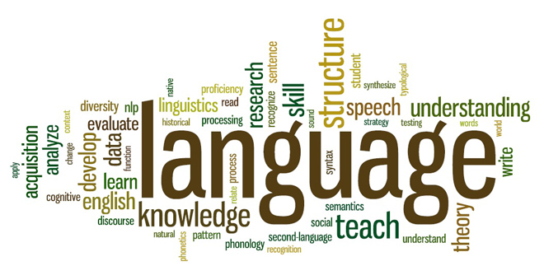
Figure 1 Caption (placed UNDER) the picture.

1.1.1 References (Headline 3)
Use the Harvard style for references, like this (Hempel 1966). Should quotes should be integrated in the text: “scientific method is important” (Hempel 1966, p. XX). Longer quotes (longer than two lines) should look like this:

Quote quote quote quote quote quote quote quote quote quote quote quote quote quote quote quote quote quote quote quote quote quote quote quote quote quote quote quote quote quote quote. quote quote quote quote quote quote quote quote quote quote quote quote quote quote quote. (Hempel 1966, p.XX).

Make sure that you follow all the rules for referring to others’ work through citations, quotations and summaries according to the rules concerning academic integrity! Always cite the original sources, and if you have not read them, the refer to both them, and to the author that cited them like this: “Language is a social institution” (Saussure 1960, p. XX), as cited by Zlatev (2018, p. YY).

Use footnotes if you need to add something that is important but not central for the argument.

Headline 4 (will not appear in contents)
Try to avoid this level of structure if you can.

Start a new chapter headline 1 on a new page.

Chapter 2 The syllabus SPVR01

2.1 Course content
In this course the student is to examine and analyse a research assignment in a subject of his or her choice independently but with the aid of a supervisor. The assignment is chosen in consultation with the supervisor and is presented in a degree project, approximately 15–20 000 words in length. With the aid of handbooks in academic writing, the student consolidates his or her ability to deal with primary and secondary sources according to the standards of scholarship. These standards comprise the fair representation of previous research, correct and efficient citation, and the correct use of established systems for references and bibliographies. During the course the student develops his or her ability to account for complex phenomena in well-written and stylistically appropriate prose.
In the final version of the thesis, it looks better if all paragraphs are left and right aligned like the above.
Also note the use of the present tense in the paragraph. Avoid using future tense, like “I will show in Section 3 that…” etc. Rather “Section 3 shows that…”. When you describe the actually empirical research, use past tense: “20 participants described the stimuli” and “The results showed that.
It is fine to use the first person singular “I” – but do not overuse it. But local traditions can vary in this, and your supervisor (and ultimately examiner) will have the final word.

2.2 Course design and assessment
Teaching consists of individual supervision and seminars. Attendance is compulsory for defence seminars in the student’s specialisation. Assessment is based on the degree thesis which the student submits and defends at a seminar. A critical review of the thesis of another student is also included in the assessment. Marking scale: Fail, Pass, Pass with distinction.
Passed degree projects at the Faculties of Humanities and Theology should preferably be registered in the LUP Student Papers database. The student is responsible for uploading the passed degree project as a PDF file in LUP student papers. Read the whole syllabus at http://kursplaner.lu.se/pdf/kurs/en/SPVR01.

Chapter 3 The MA thesis defence
All programme students will be invited to The MA thesis defence, and it will be announced in the SOL calendar. An approximate timetable for the defence is the following:
- A chairman (usually the supervisor) states the agenda, including time frames, and asks if the student wishes to note any errors.
- The student presents the thesis. (20-30 min)
- The opponent, prepared according to instructions, leads the opposition. (20-30 min)
- The examiner asks questions. (5-10 min)
- The audience asks questions. (5-10 min)
- Supervisor, Examiner and (preferably) Coordinator meet to determine the grade and necessary corrections.
- Opponent’s written response (1-2 pages) and information on grade and necessary corrections are sent to Coordinator for documentation.

References
Hempel, Carl G.(1966). Philosophy of natural science. Englewood Cliffs: Prentice- Hall.
Kuhn, Thomas S.(1996). The Structure of scientific revolutions. (3rd ed.). Chicago, Ill.: University of Chicago Press.
Saeed, John I. (2011) Semantics. (3rd ed.) Hoboken: John Wiley & Sons.
Popper, Karl (2005). The logic of scientific discovery. (2nd ed.) London: Routledge.

Appendix
In the appendix (which can be divided in Appendix A, B, C…), you put long tables, lists of examples, questionnaires and other data. The appendix does not add to the word count.

But not for references.

