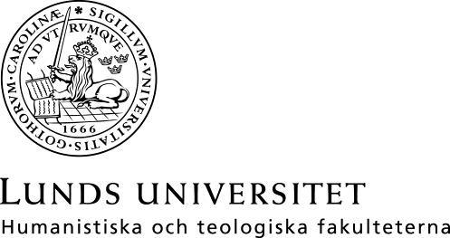

Språk- och litteraturcentrum Filmvetenskap

Kurslitteratur för FIVK01 Filmvetenskap, kandidatkurs 1–30 hp,
FIVK01 Filmvetenskap, kandidatkurs 1–30 hp, vt 20201 (Fastställd i Sektionsstyrelse 2, SOL-Centrum, 8 dec 2020)

Delkurs 1: Filmanalytisk teori och metod, 7,5 hp

Bordwell, David (1997 eller senare), On the History of Film Style, Harvard University Press, 320 s.

Gibbs, John (2002), Mise-en-scène: Film Style and Interpretation. London: Wallflower 128 s.

Orpen, Valerie (2003), Film Editing: The Art of the Expressive. London: Wallflower, 138 s.

Reay, Pauline, (2004), Music in Film: Soundtracks and Synergy.
London: Wallflower, 135 s.

Street, Sarah (2001), Costume and Cinema: Dress Codes in Popular Film. London: Wallflower, 112 s.

Thompson, Lara (2011), “In Praise of Speed: The Value of
Velocity in Contemporary Cinema”, DANDELION (2:1), s. 1 – 15.

Texter om filmteori tillkommer, kopplade till de specifika analysobjekt som behandlas i kursen. Texterna hämtas fritt online, huvudsakligen via LUBSearch.

Resurslitteratur:
Gocsik, Karen, Barsam, Richard & Monahan, Dave (2013 eller senare), Writing about Movies, tredje upplagan. New York & London: Norton

Hayward, Susan (2006 eller senare), Cinema Studies: The Key Concepts, London: Routledge. Tillgänglig via LUBSearch.

Kuhn, Annette & Westwell, Guy (2012), A Dictionary of Film Studies. Oxford: Oxford University Press. Tillgänglig via LUBSearch.

The Routledge Encyclopedia of Film Theory (2014), Branigan, Edward & Buckland, Warren. London & New York: Routledge. Tillgänglig via LUBSearch.

