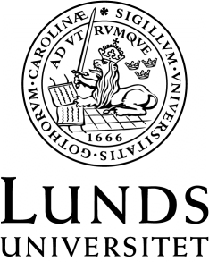
Språk- och litteraturcentrum
Filmvetenskap
Required reading for
FIVA05: Scandinavian and European Film Culture (1-30 ECTS) Autumn 2020, Course 1
or
FIVA06: Culture and History in Film and Television (7, 5 ECTS) Autumn 2020
(Fastställd i Sektionsstyrelse 2, SOL-Centrum, 2 juni 2020)
Breger, Claudia (2020). Making worlds: affect and collectivity in contemporary European cinema. New York: Columbia University Press (336 pp) (Select reading, ca 150pp)
Higson, Andrew (2011). Film England: culturally English filmaking since the 1990s. London: I. B. Tauris. (296 pp.)
Screening European heritage: creating and consuming history on film (2016). Cooke, Paul & Stone, Rob (red.) Basingstoke: Palgrave Macmillan (290pp) (Select reading, ca 150pp)
Vidal, Belén (2012). Heritage Film: Nation, Genre and Representation, London: Wallflower. (144 pp.)
White, John (2017). European art cinema. London: Routledge (287pp)
Additional readings available online or via the course platform. (Ca 150 pp.)

